

Level-up CSP Technical Training – Power Platform Facilitator Guide

Building and Publishing Multilingual Agents in Microsoft Copilot Studio

|  |  |
| --- | --- |
| Description | In this lab, participants will learn how to access Microsoft Copilot Studio, create a multilingual AI-powered agent, enrich it with external knowledge sources, and publish it for testing. The lab focuses on configuring environments, building agents using natural language prompts, enabling language localization, and validating agent responses in English and French. |
| Prerequisites | Participants need a Microsoft 365 work or school account with admin rights, access to Microsoft Copilot Studio (trial or active license), and the ability to access Power Platform Admin Center. A modern browser (Edge recommended) and a VM with required lab files, including the localization JSON, are also needed. |
| Duration | 30 min |
| Version | 1.0 |
| Publication date | July 2024 |

This document is provided “as-is”. Information and views expressed in this document, including URL and other Internet Web site references, may change without notice. You bear the risk of using it.

This document does not provide you with any legal rights to any intellectual property in any Microsoft product. You may copy and use this document for your internal reference purposes.

© 2024 Microsoft. All rights reserved.

## Exercise 1: Accessing Microsoft Copilot Studio

In this exercise, you will begin by accessing Microsoft Copilot Studio, the platform where you will create and manage AI-powered copilots. Depending on your participation on Day 1 and your trial license status, you will either proceed with signing in directly or start a free trial. This setup ensures you have access to the correct environment—MOD Administrator—which will be used throughout the lab. Completing this step is essential before you can begin building or managing any copilots.

**Note:** If you attended Day 1 and have already activated the free trial of Copilot Studio, please complete Task 2 and skip Task 1. If you did not attend Day 1 and do not have a Copilot Studio free trial license, please skip Task 2 and complete Task 1.

### Task 1: Start Free Trial Copilot Studio

1. Open a Microsoft Edge new tab and navigate to copilot studio website https://www.microsoft.com/en-us/microsoft-copilot/microsoft-copilot-studio and select the Try free.

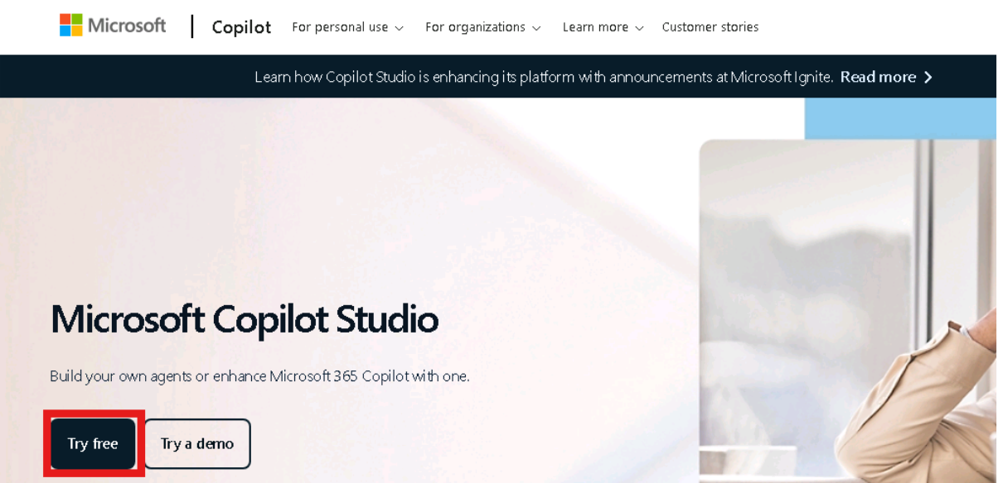

1. In the Email box, enter admin tenant and then select Next.

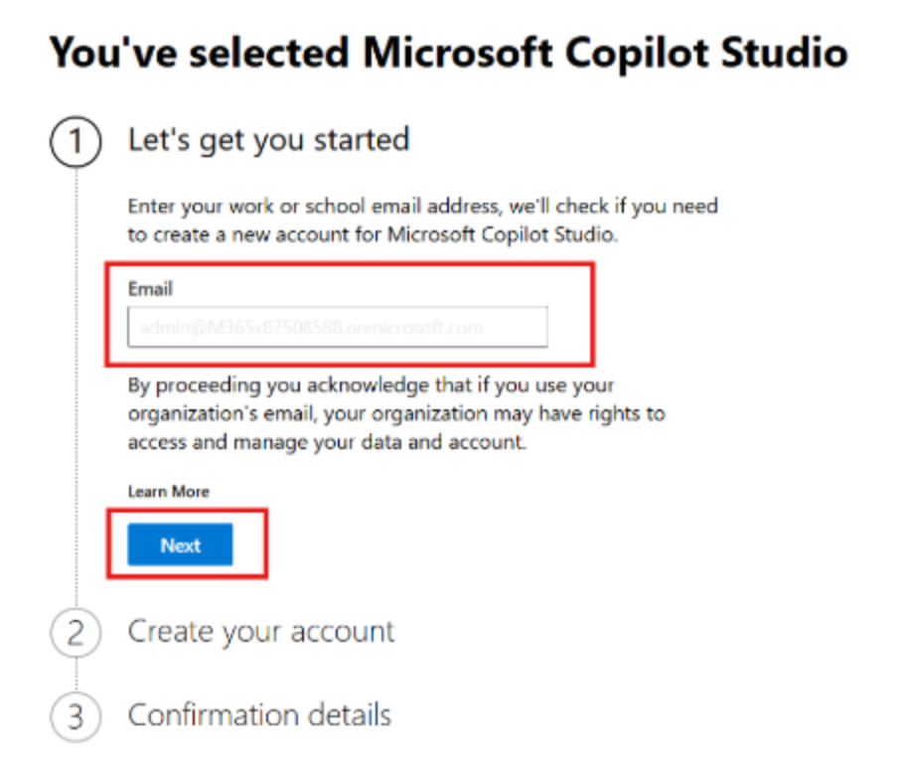

1. Select Sign In.
2. If prompted, in the Password box, enter admin tenant password and then select Sign in.

If you are prompted with a message stating You already have a license for Microsoft Copilot Studio, select Get Started.

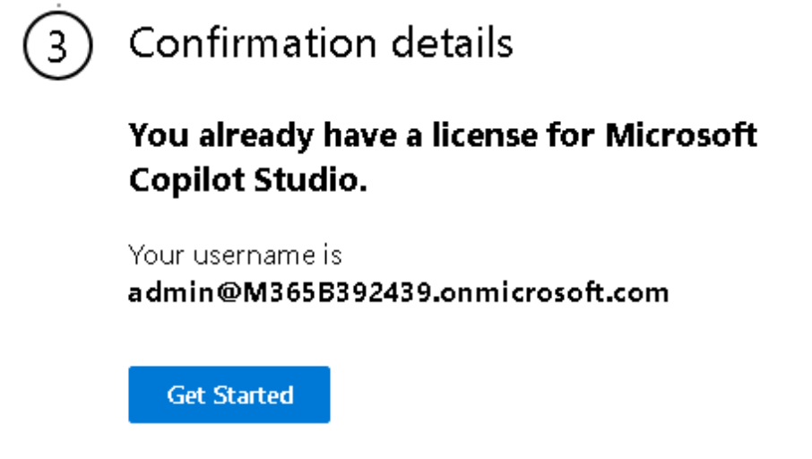

1. Enter Country or Region and Business phone number in the respected fields. Select the check box and select Get started button.

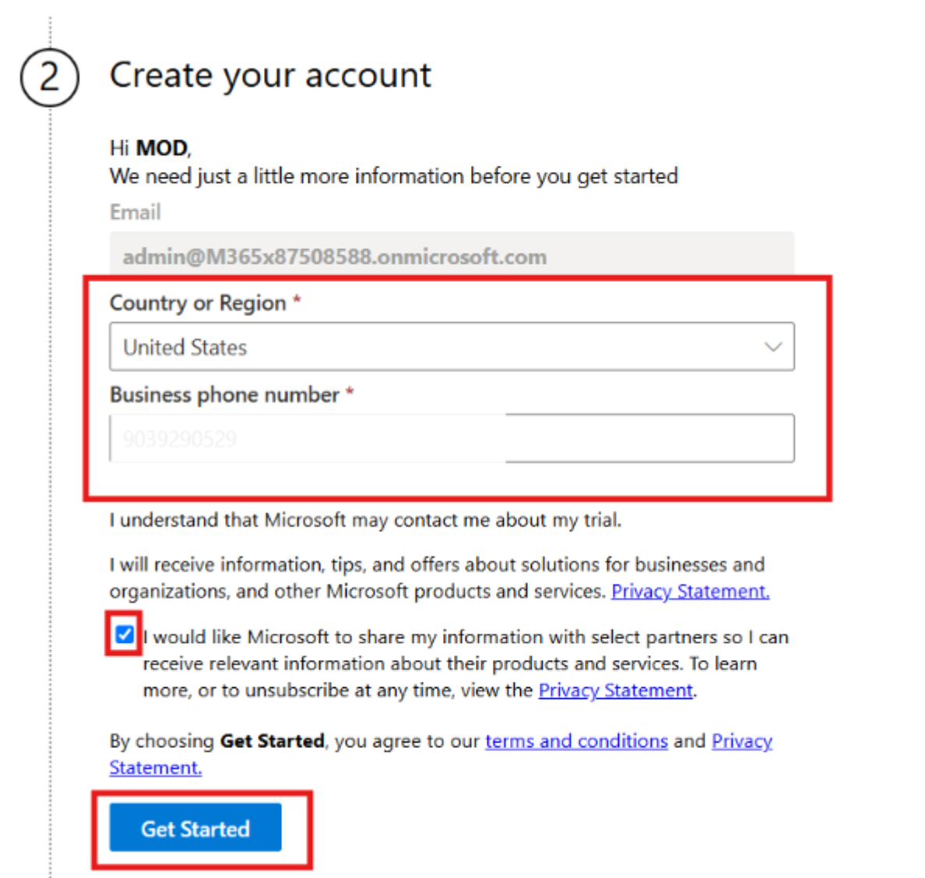

1. In the confirmation section again select the Get Started button. In the Welcome to Microsoft Copilot Studio dialog box, select Skip.

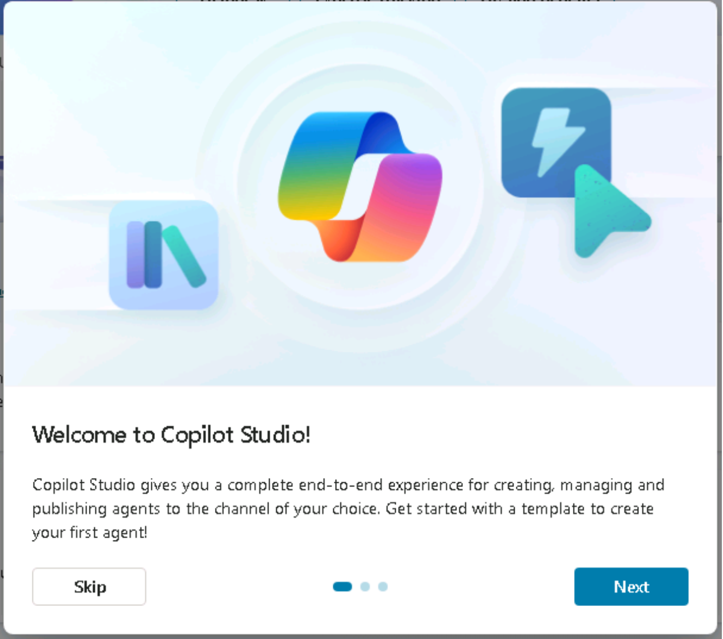

1. Once you're signed in, look at the top-right corner of the screen. Choose the environment, we use MOD Administrator environment for this lab. This is important for the next steps, as you'll need to select this environment when working in Power Apps.

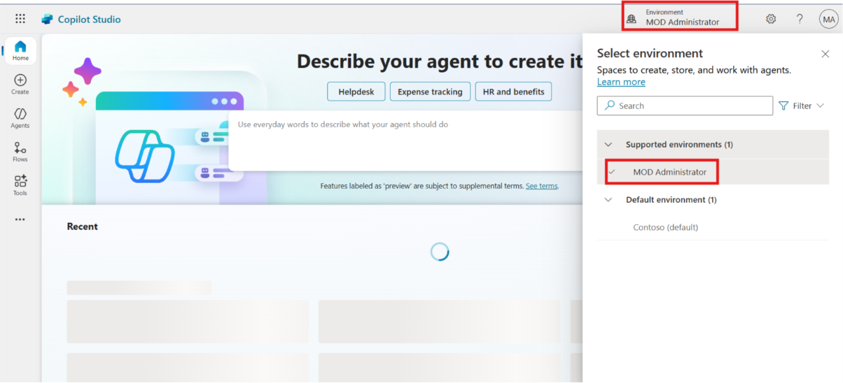

**Caution: If you don't see Mod Administrator follow these steps**

**Steps to Create a New Power Platform Environment if you don't have "Mod Admin"**

1. Open edge browser and navigate to https://admin.powerplatform.microsoft.com (Power Platform admin center). Enter given below admin tenant in the field and then select the Next button to proceed.

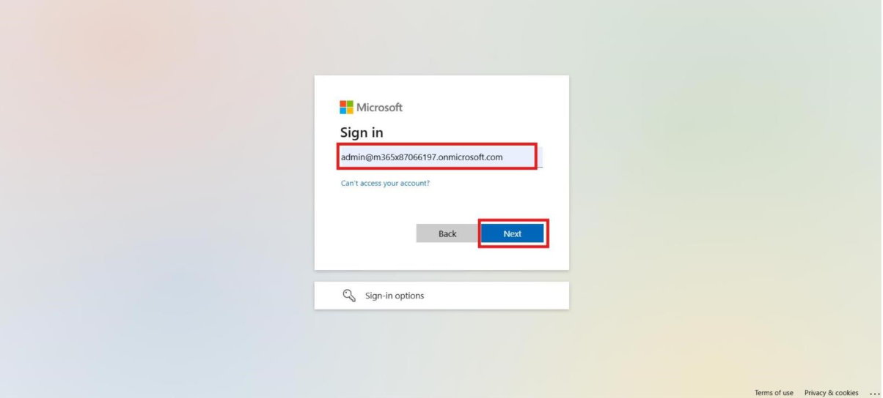

1. Enter Admin Password in the field and select the Sign in.

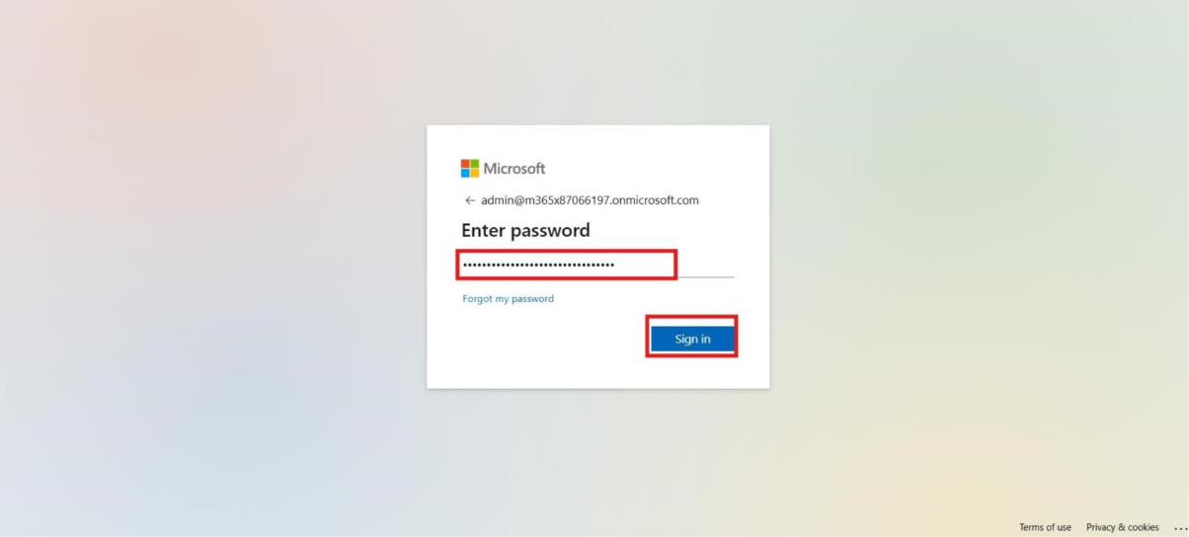

1. Select the Yes to stay signed in.

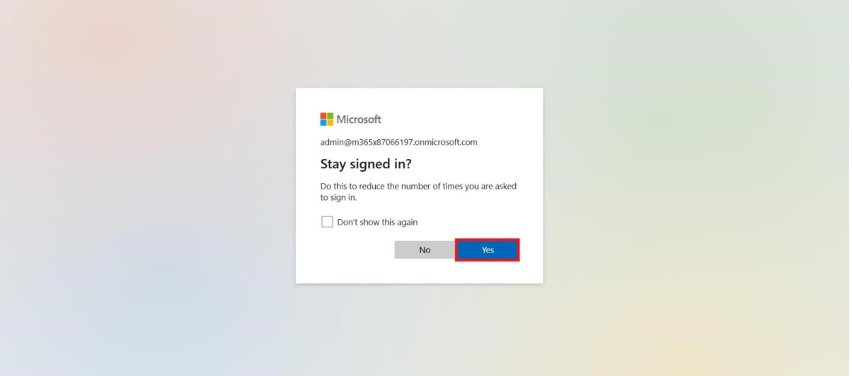

1. From the left menu, select Manage, participant navigate to environments page, then select + New to create a new environment.

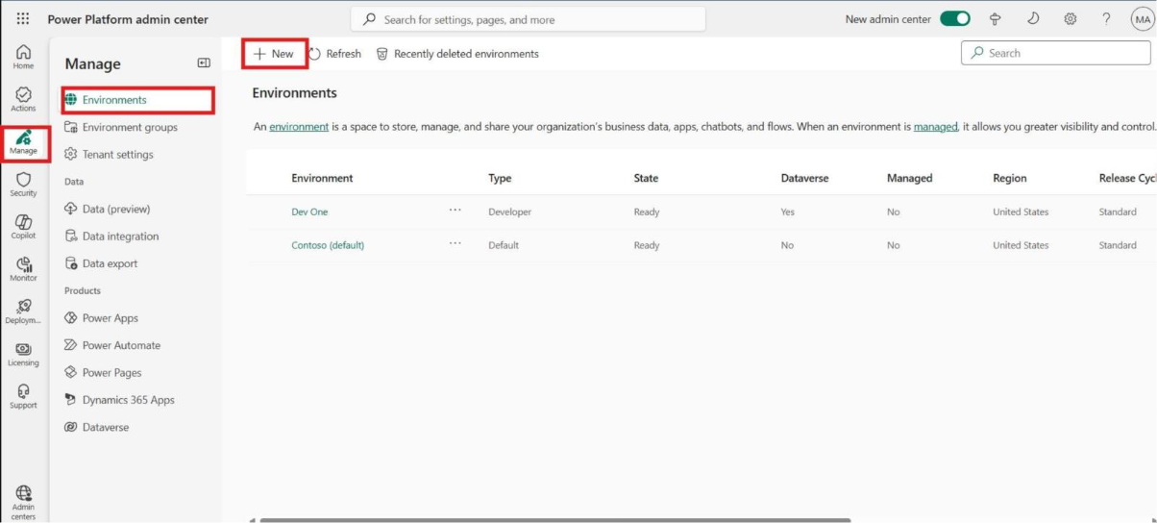

1. In the Name field, type MOD Administrator. Select "Developer" as the environment type and select Next.

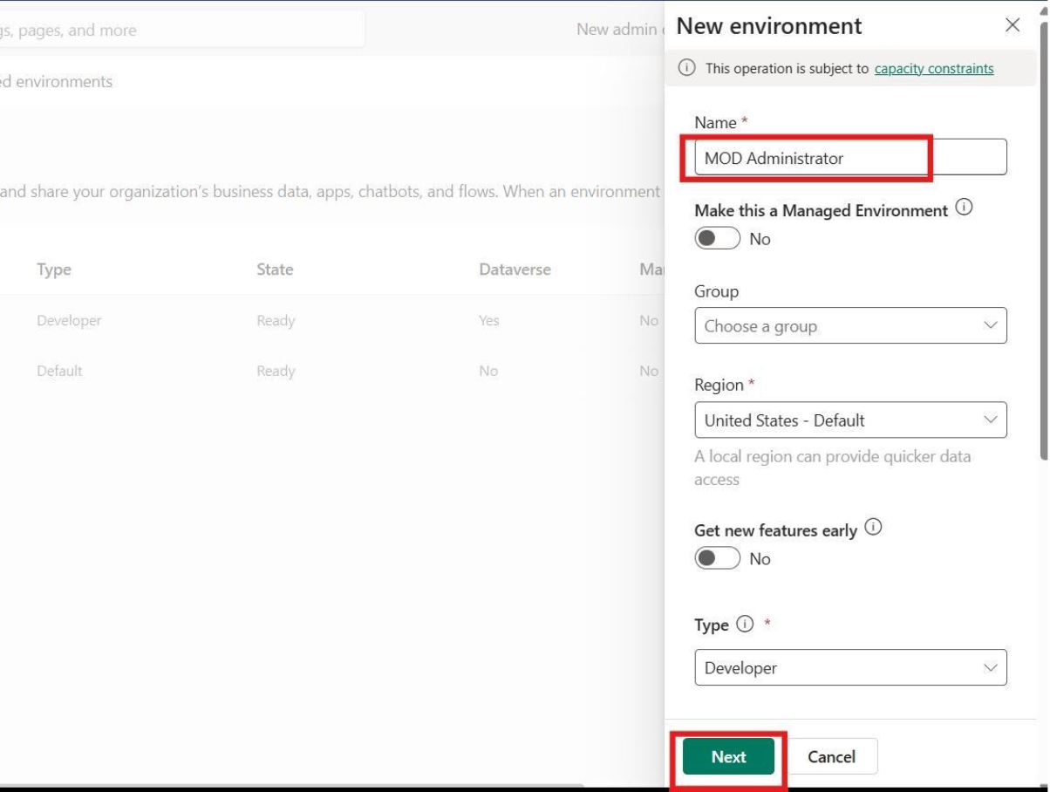

1. Choose your preferred language (for this lab guide, we are using English) and turn "Yes" for "Deploy sample apps and data." Select Save to begin the environment creation process.

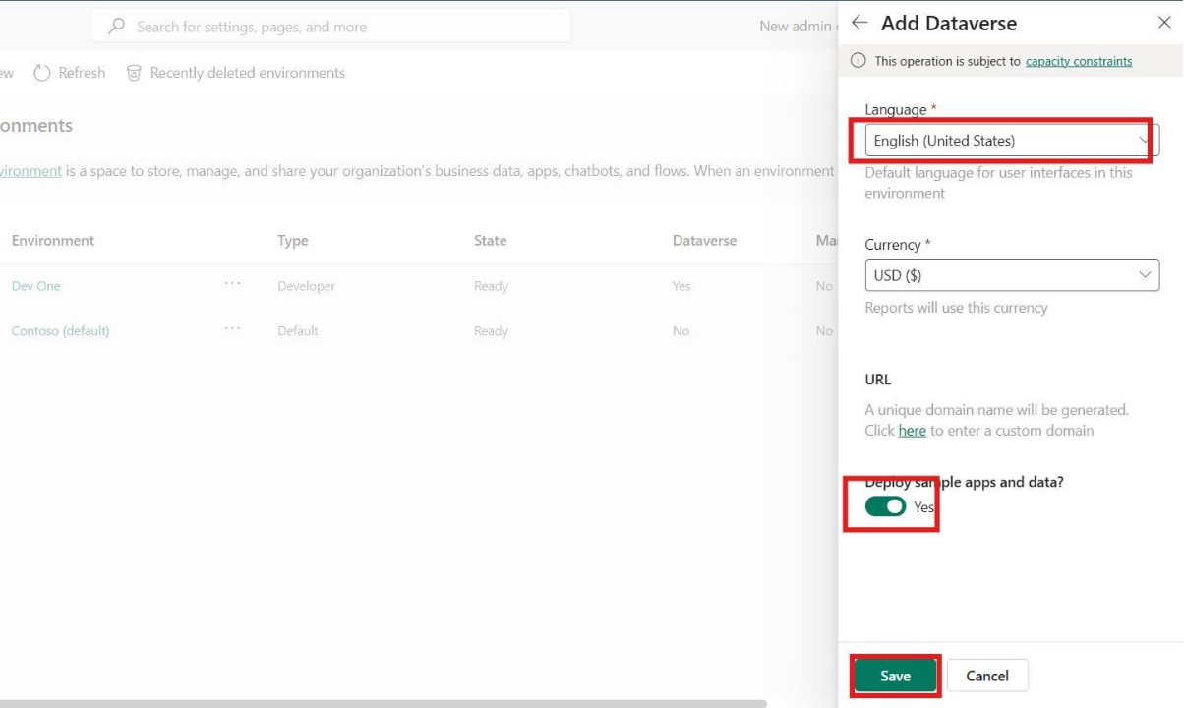

1. Wait a few minutes until the environment status displays Ready.

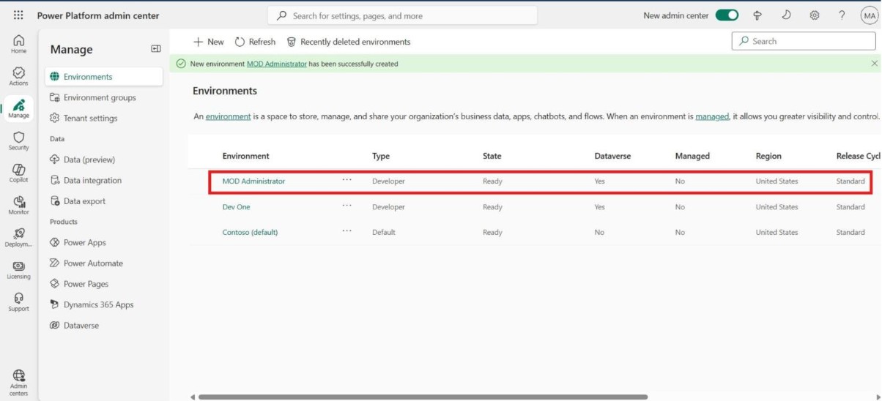

1. Navigate back to copilot studio and select Mod Administrator Environment.



### Task 2: Sign In to Microsoft Copilot Studio (For Participants with Active Trial)

1. Open a Microsoft Edge new tab and navigate to copilot studio website https://www.microsoft.com/en-us/microsoft-copilot/microsoft-copilot-studio and select the Sign in from top right corner.

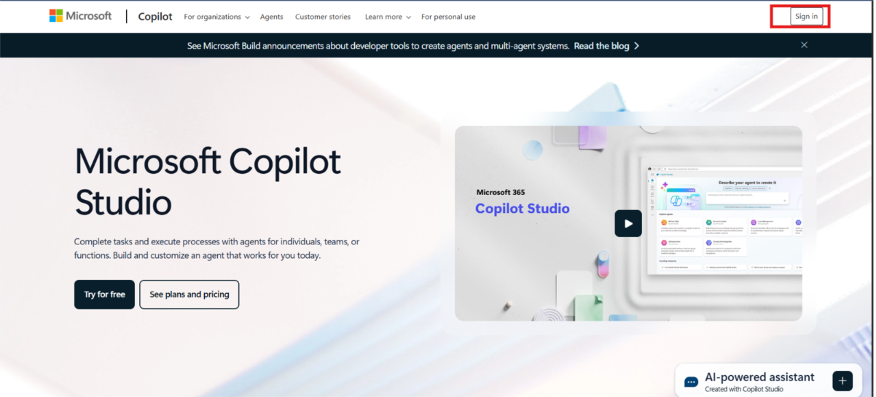

1. Enter Admin Tenant ID in the field and then click on the Next button to proceed.

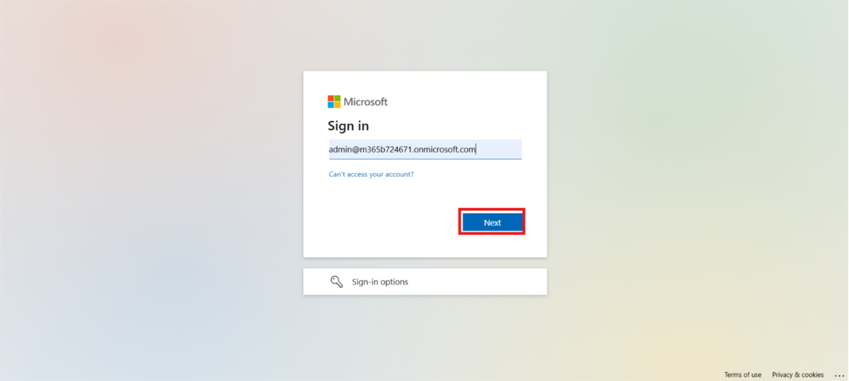

1. Enter Admin Password in the respected field and Click on the Sign in button.

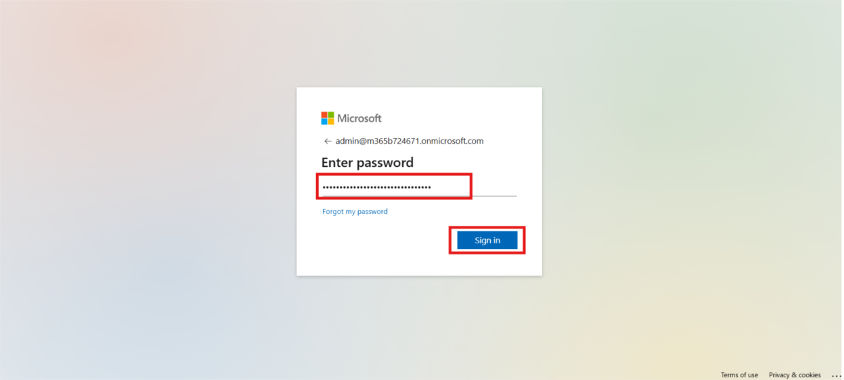

1. Click on the Yes button to stay signed in.

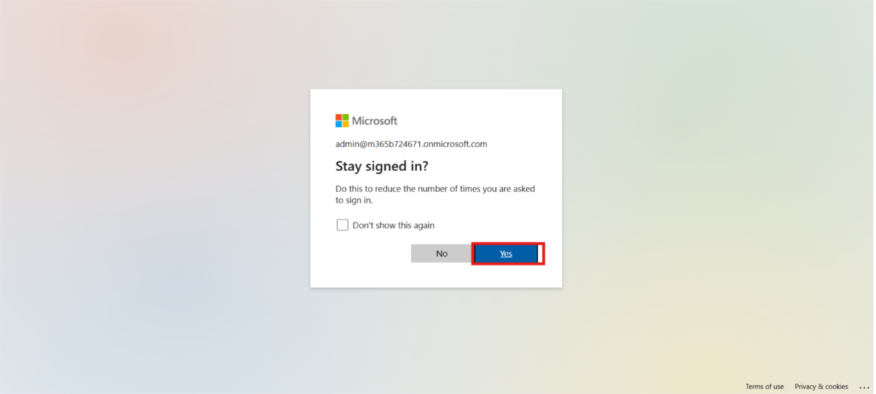

1. Once you're signed in, look at the top-right corner of the screen. Choose the environment, we use MOD Administrator environment for this lab. This is important for the next steps, as you'll need to select this environment when working in Power Apps.

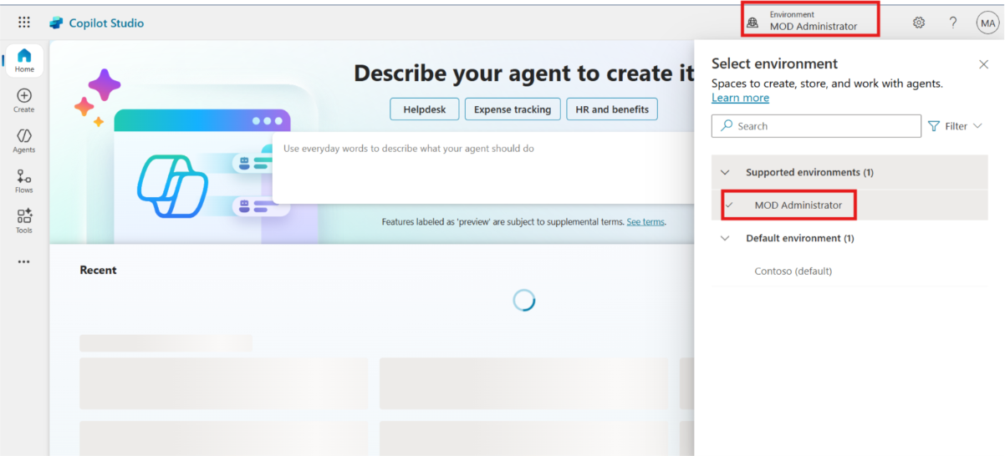

### Conclusion

1. Learned how to sign in to Microsoft Copilot Studio using an existing trial license
2. Understood how to start a free trial for Copilot Studio if not already activated
3. Identified how to switch to or create the “MOD Administrator” environment
4. Gained experience navigating both Copilot Studio and Power Platform Admin Center
5. Ensured the correct setup needed for building and testing copilots in upcoming exercises

## Exercise 2: Create a Copilot Studio Learning Agent

In this exercise, participants will learn how to create a new agent in Microsoft Copilot Studio using a custom prompt. This agent will serve as a learning assistant to help users navigate various Copilot Studio capabilities.

1. From the left-hand menu, navigate to **Agents** and click on **+ New agent**.

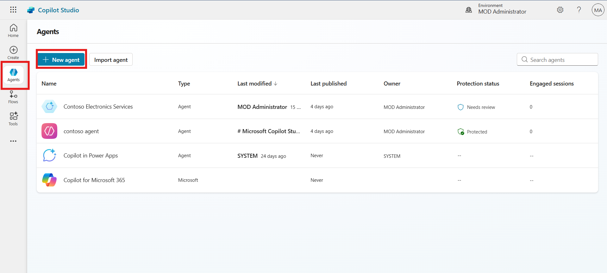

1. From right hand side, participants can change the primary language of the agent. For this lab guide using **English** as primary languages.

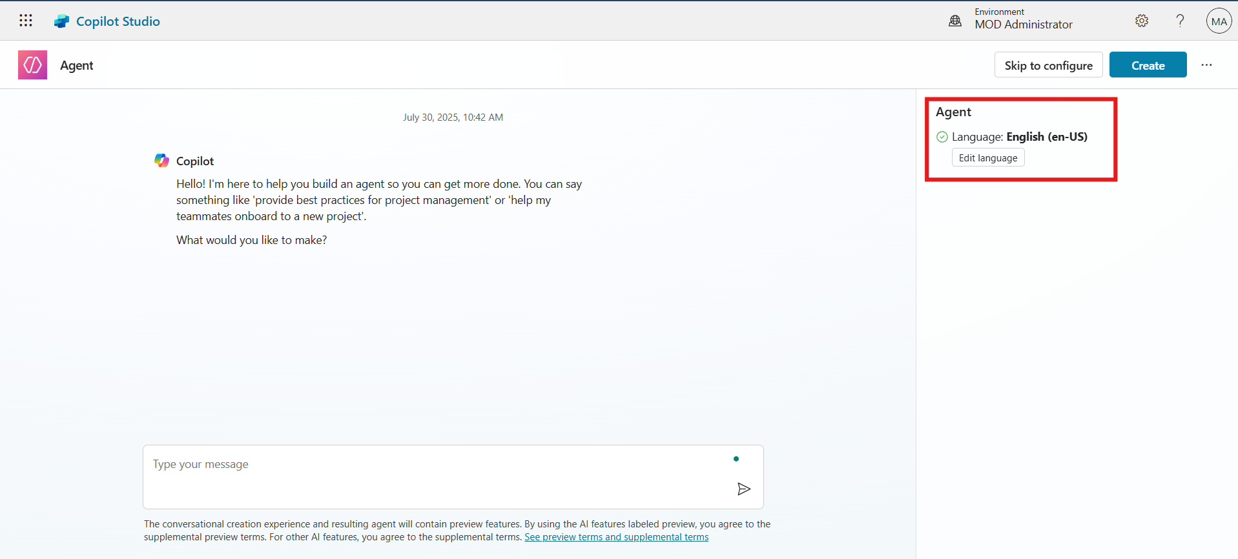

1. In the **prompt input field**, paste the following prompt and then click on the **Execute** button to run the prompt.

Create a virtual agent that serves as a comprehensive learning assistant for Copilot Studio. The agent should guide users through all aspects of Copilot Studio, including getting started, key features, licensing, agent creation, publishing, integration, advanced capabilities (e.g., generative answers, APIs), and best practices. The agent must support FAQs, provide interactive guidance, and recommend official Microsoft resources, documentation, and learning paths. It should be user-friendly, accessible to both beginners and advanced users, and capable of answering contextual follow-up questions.

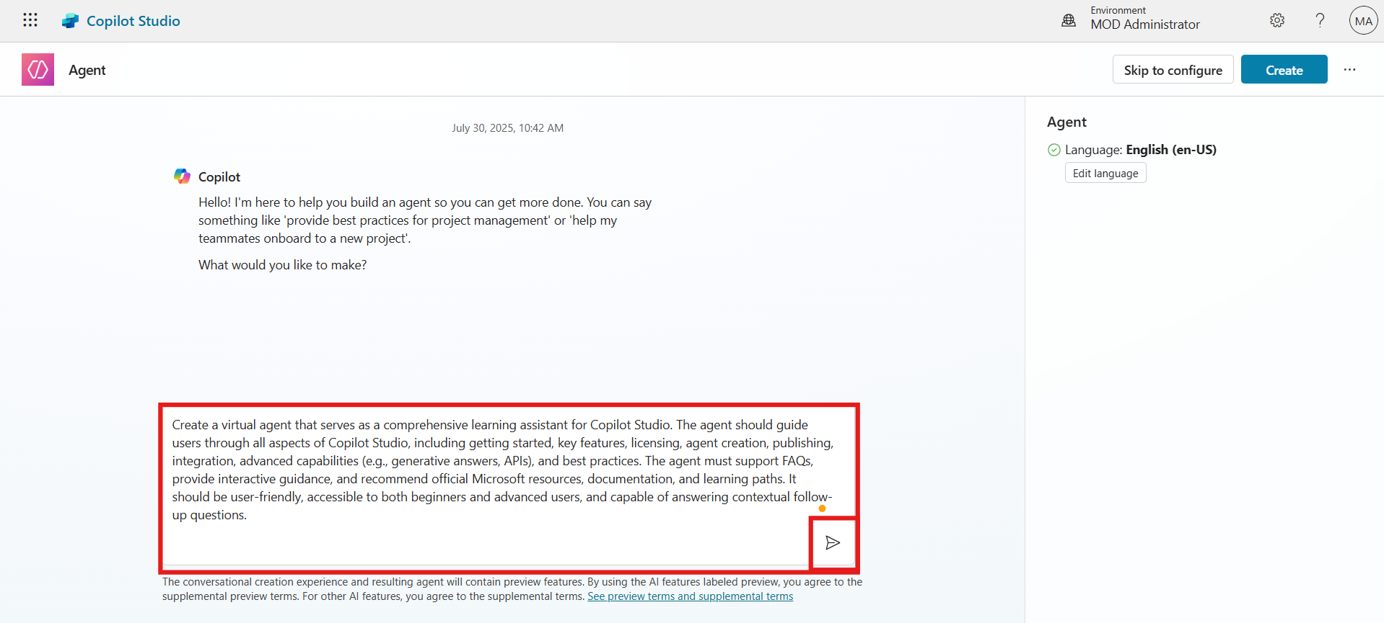

1. Type **Confirm** in the field and click **Execute**.

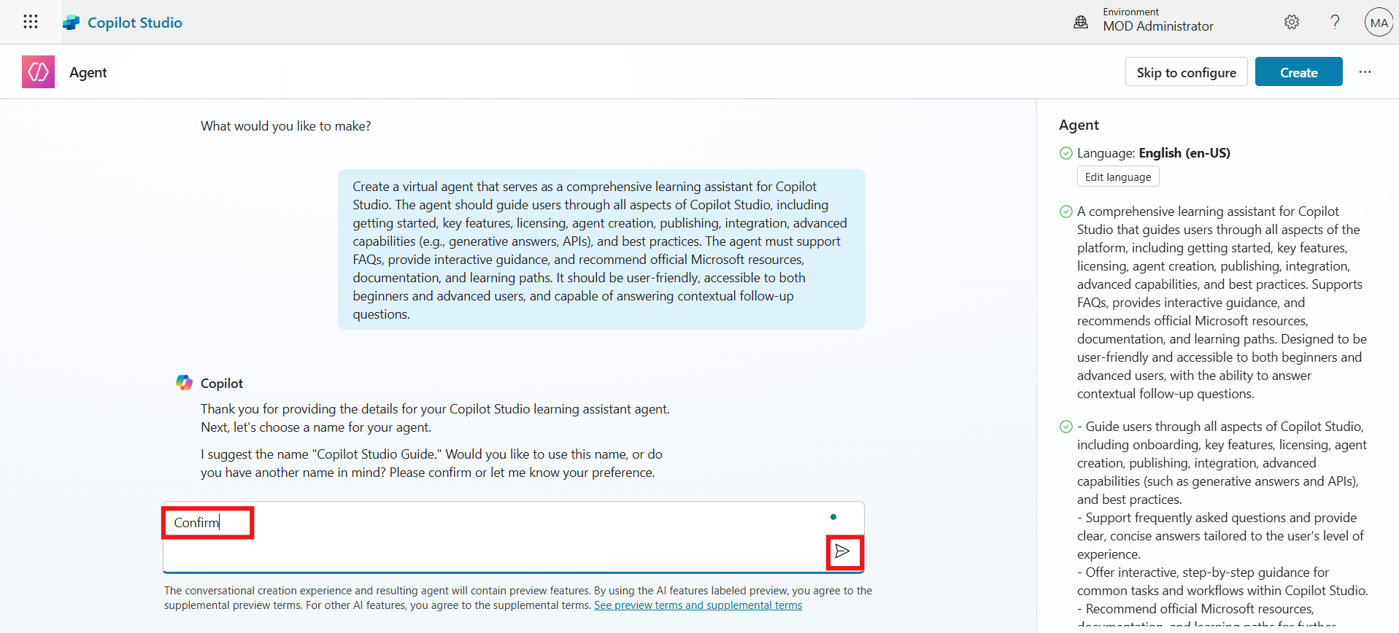

1. Click the **Create** button from the top-right corner to generate the agent.

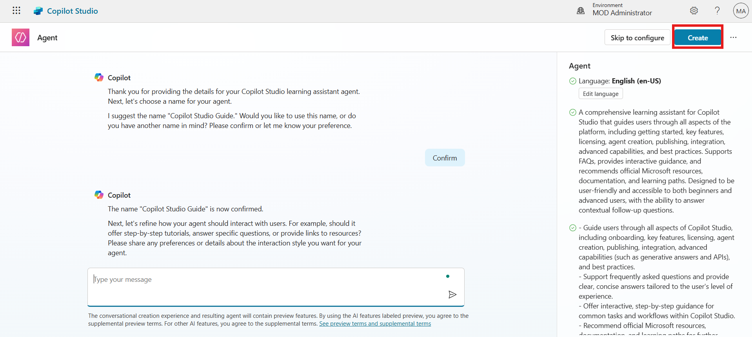

### Conclusion

* Created a new virtual agent using a detailed natural language prompt.
* Chose **English** as the agent’s default language.
* Executed and confirmed prompt to create the agent in Copilot Studio.

## Exercise 2: Add Knowledge Source to the Agent

This exercise guides participants in enriching the agent’s responses by connecting it to a live Microsoft documentation website using the knowledge source feature.

1. On the agent overview page, scroll down and click **+ Add knowledge**.

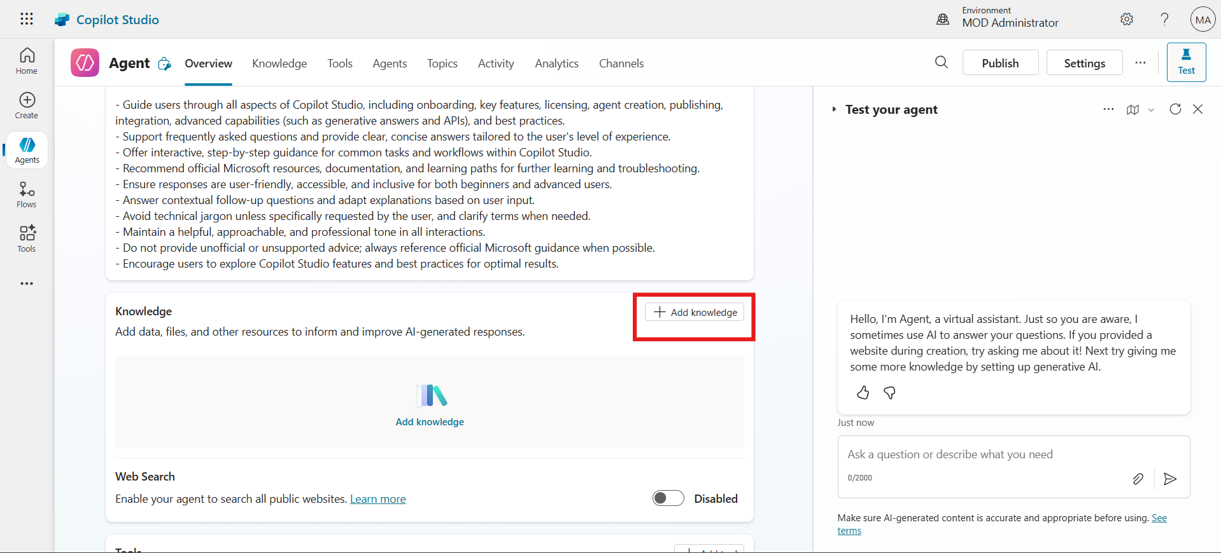

1. Choose **Public Website** as the knowledge source type.

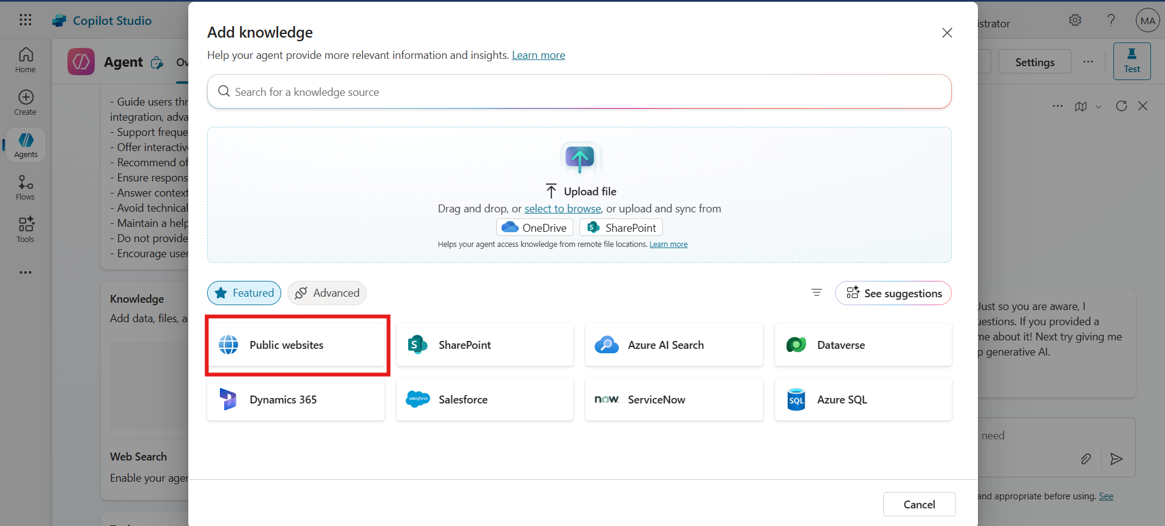

1. In the URL field, enter <https://learn.microsoft.com/en-us/microsoft-copilot-studio> and then click on the **Add** button.

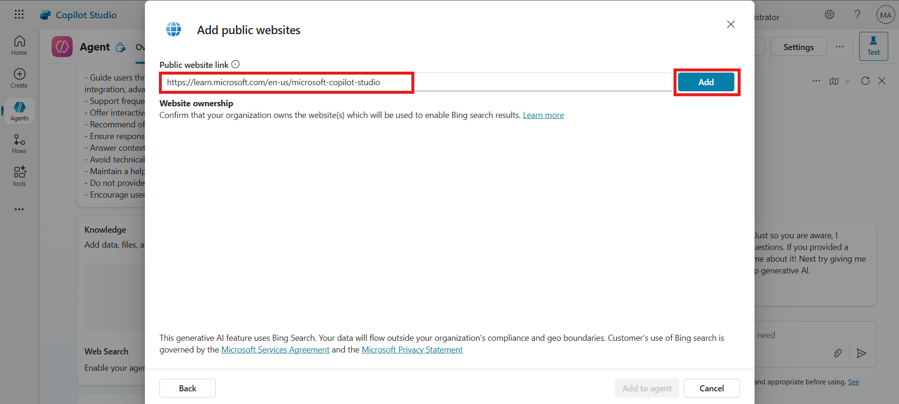

1. After adding URL, Click **Add to agent** button to proceed.

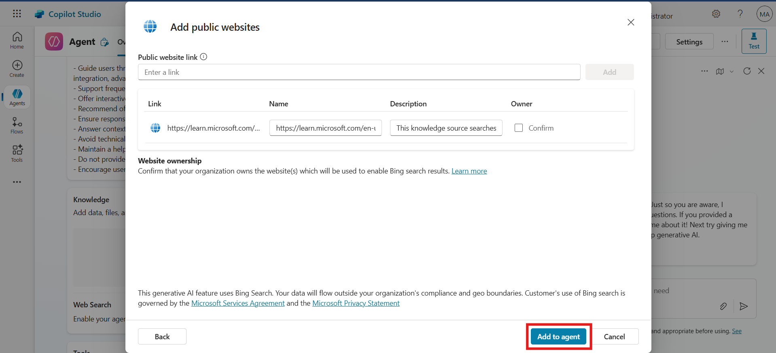

### Conclusion

* Successfully linked a **public documentation site** to the agent.
* Enabled the agent to provide richer and more accurate responses.
* Integrated **Microsoft Learn** content into the Copilot Studio agent.

## Exercise 3: Enable Multilingual Support and Publish Agent

This final exercise enables multilingual support for the agent by adding French as a secondary language, uploading localization files, and publishing the agent.

1. Navigate back to the **Agent Overview** page. Go to **Settings** from top menu bar.

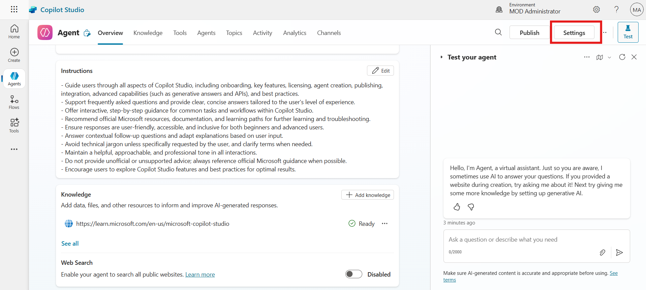

1. From the setting menu navigate to languages section. First option is for primary languages, participants can change the primary language. For this lab guide we are using English as primary language.

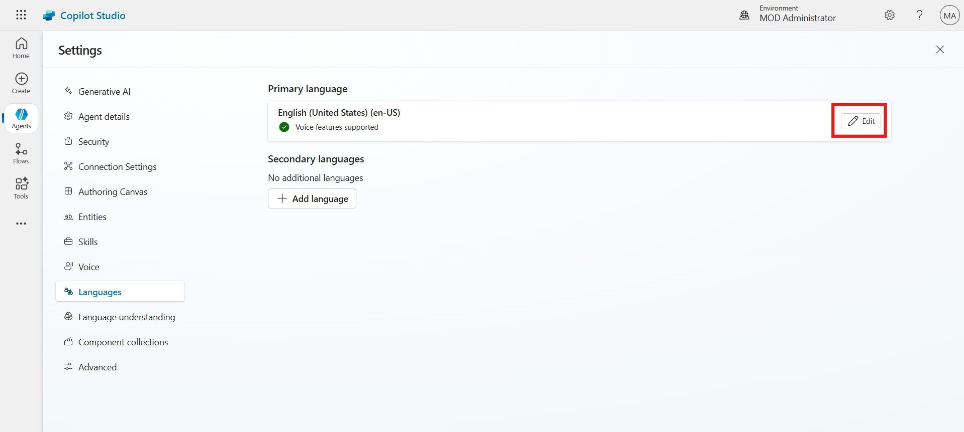

1. Click **+ Add language** to add secondary language.

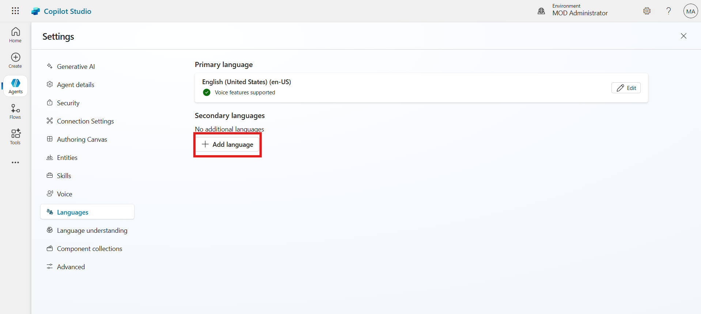

1. Search for **French (France)**, Select check box of the language and then click on the **Add**.

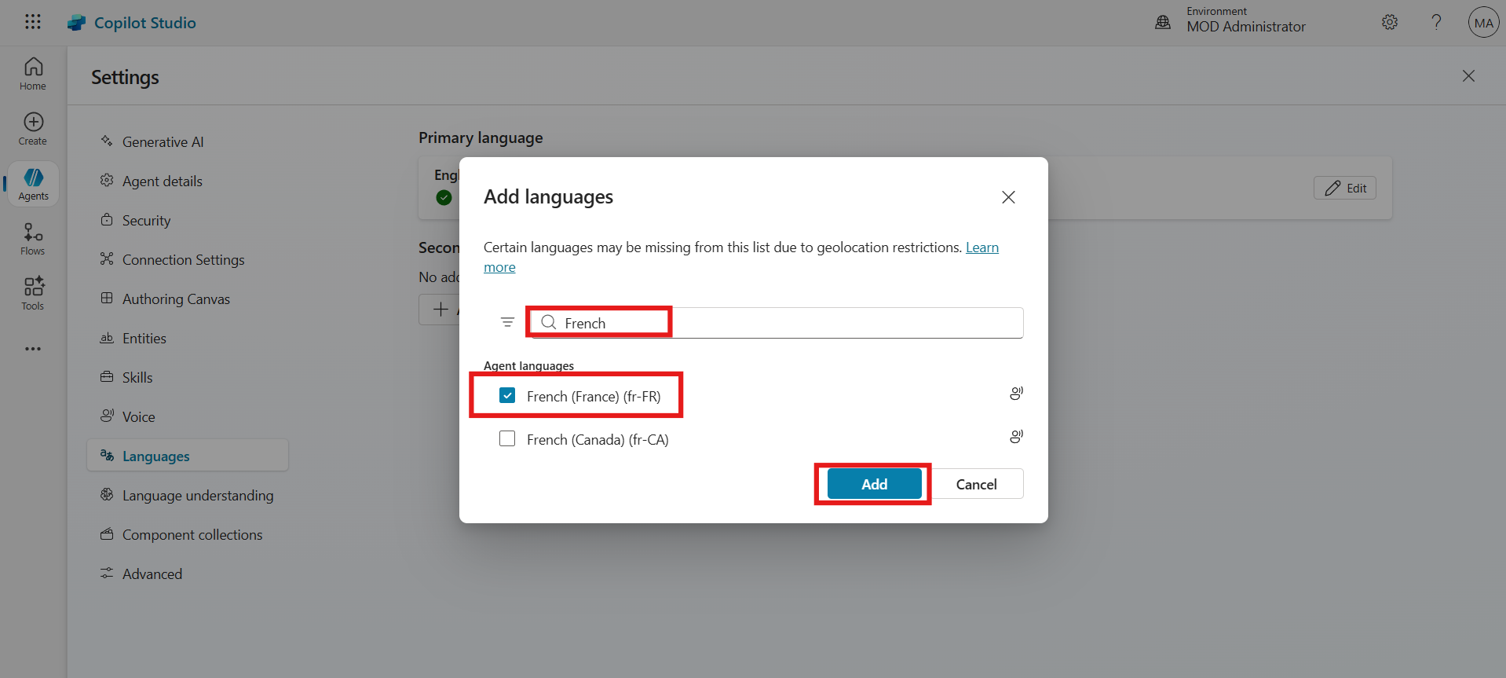

1. After adding the secondary language, click on the **Upload** button to add localization file.

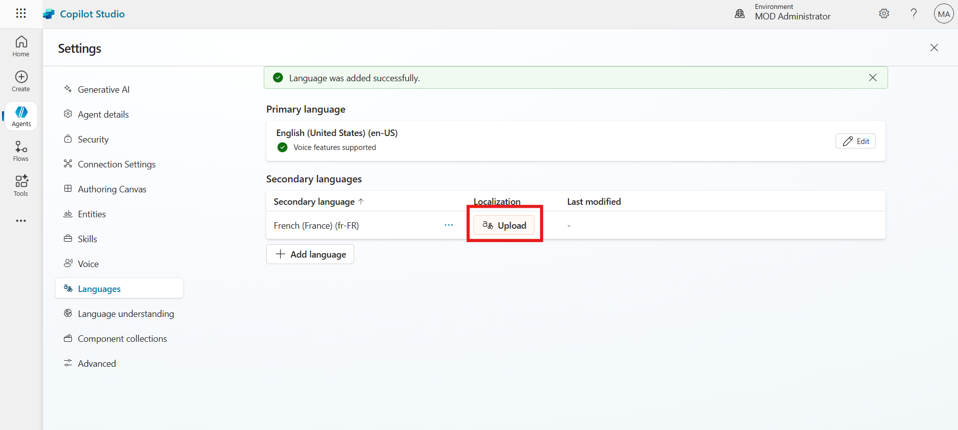

1. Click **Download localization file** (JSON format) to download file.

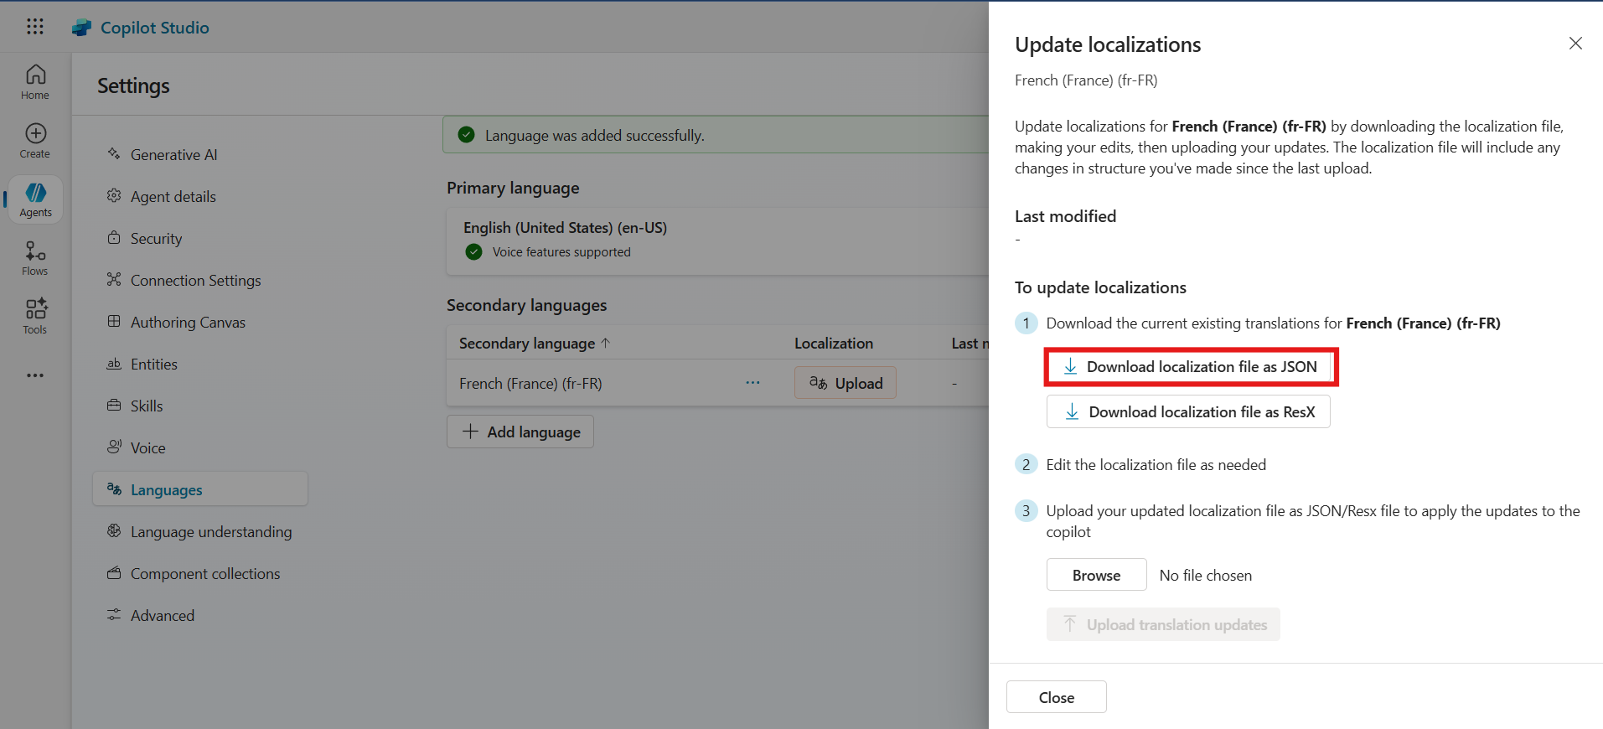

1. The localization file is downloaded successfully and its available in the VM downloads folder. Participant need to update the localization file in French. For this lab guide we already updated the localization file and added in the lab file folder.

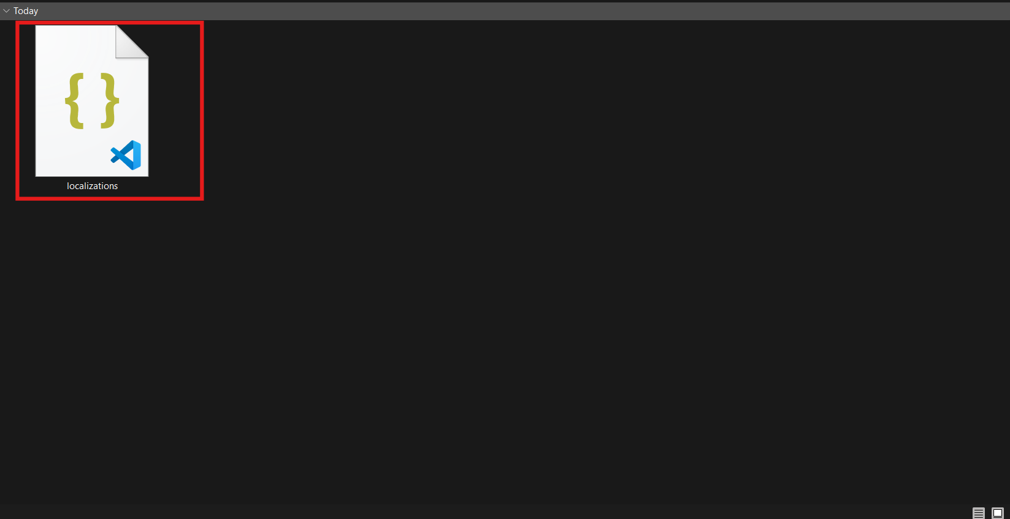

1. Click **Browse**, select the localization_FR file, and click **Open**.

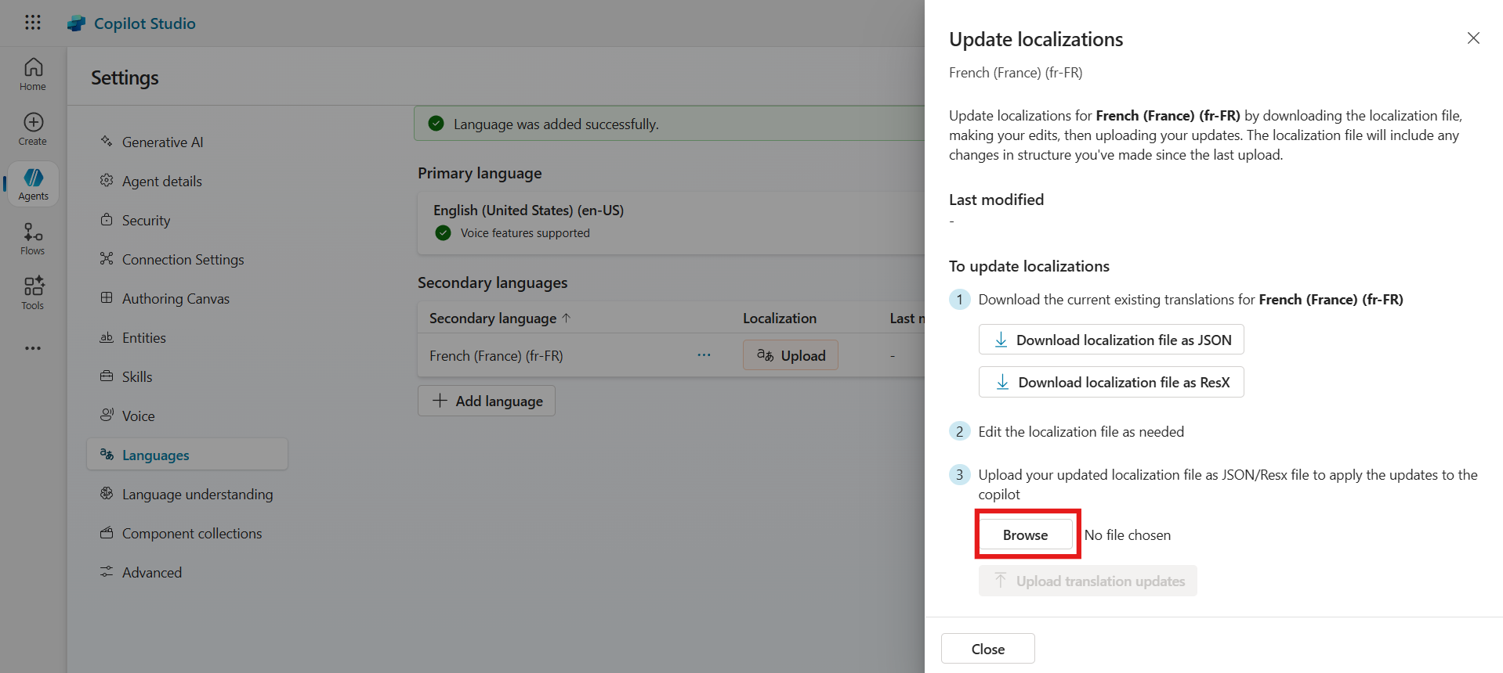

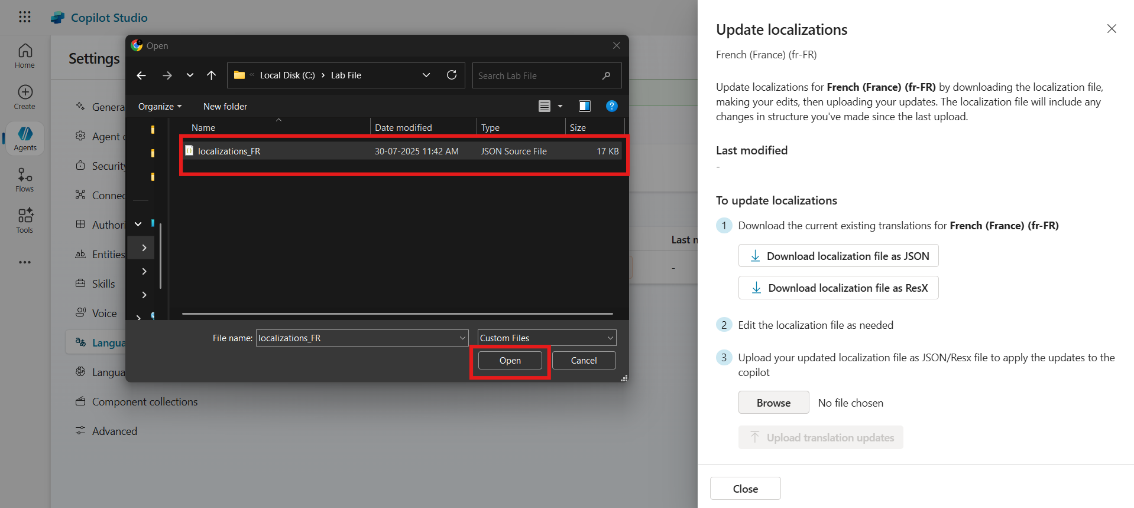

1. Click **Upload translation updates**, then For confirmation click **Upload localization** again.

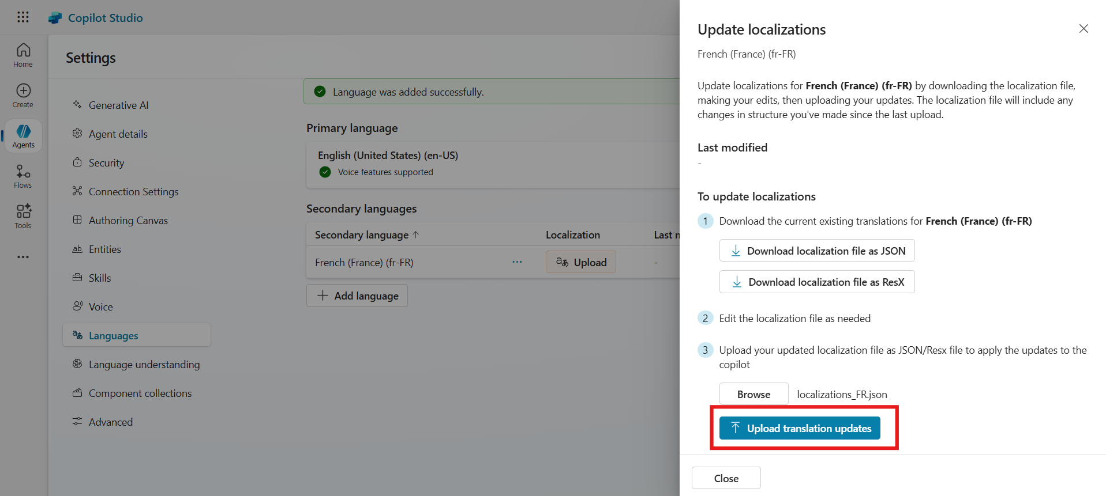

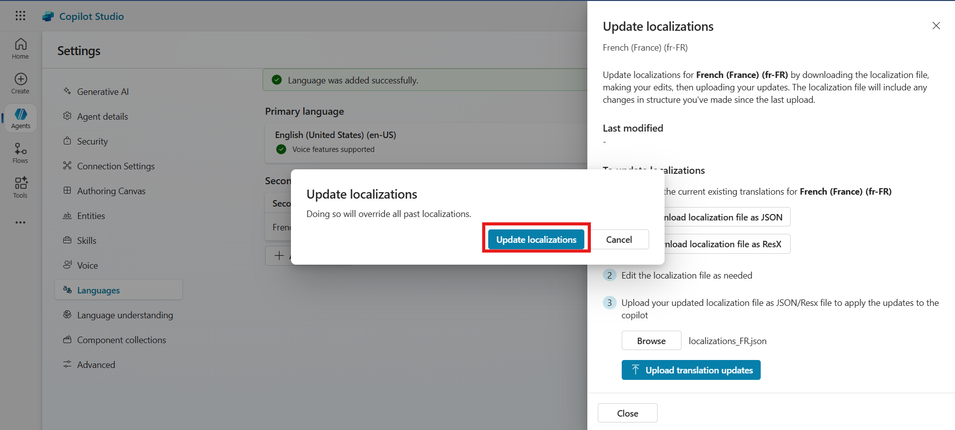

1. Then click on the **Close** button.

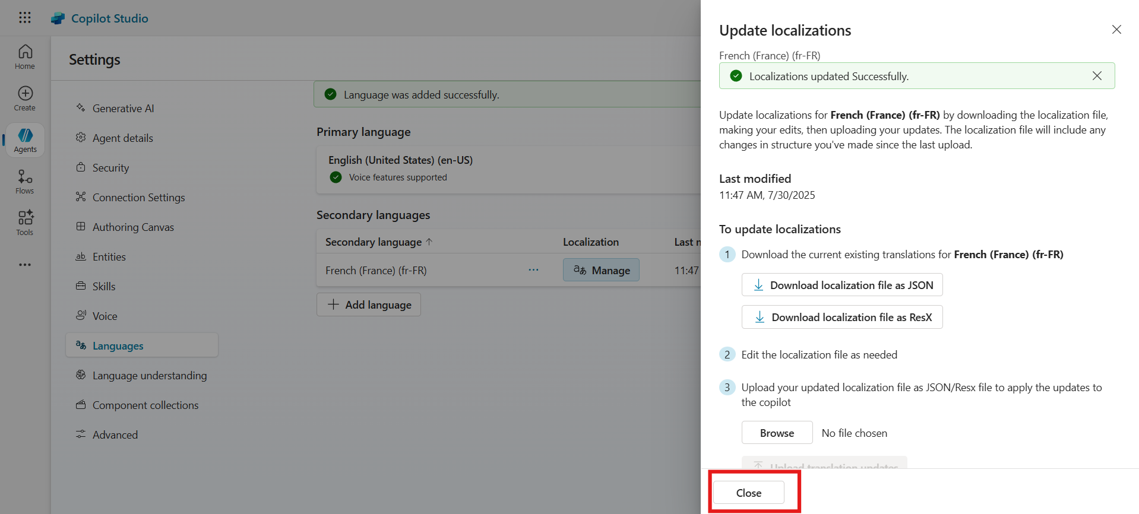

1. Return to **Agent Overview** and click **Publish** from the top bar.

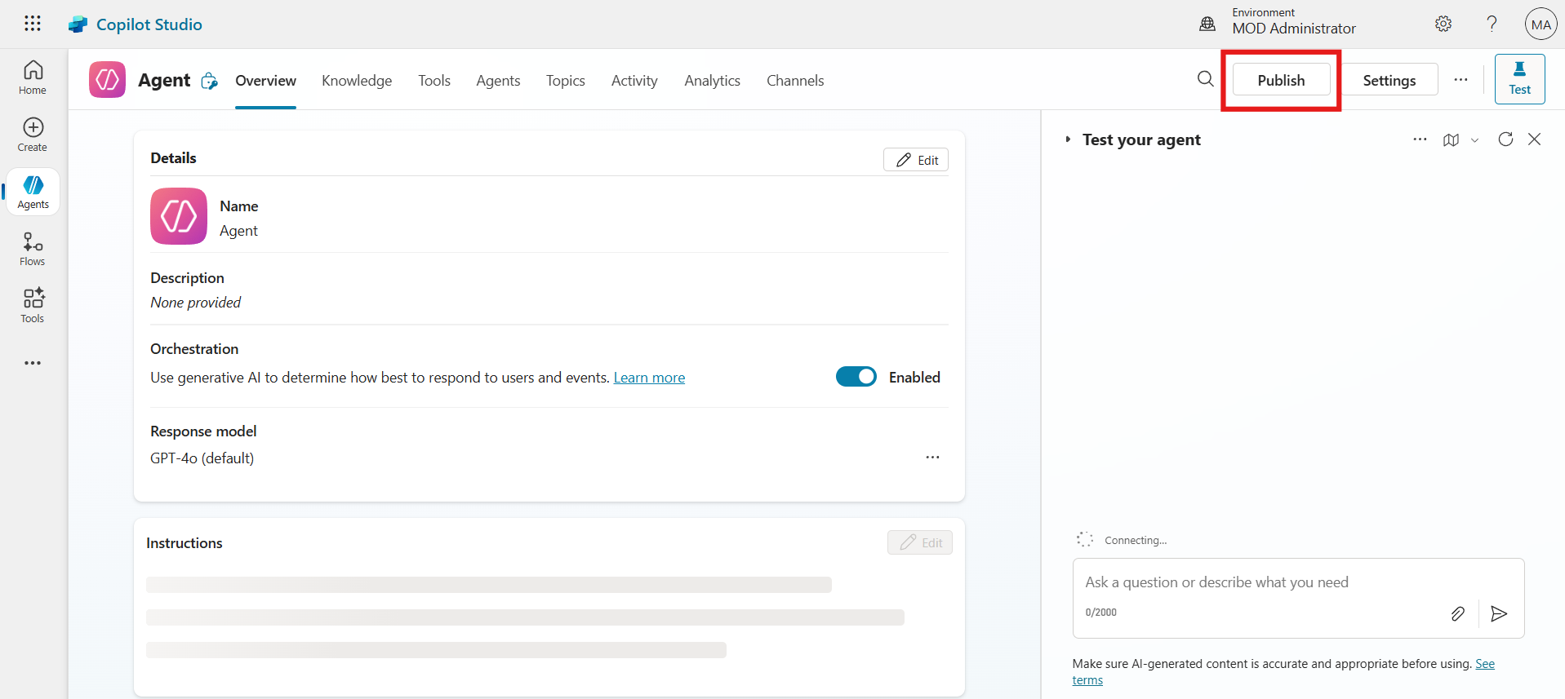

1. Confirm by clicking **Publish** again.

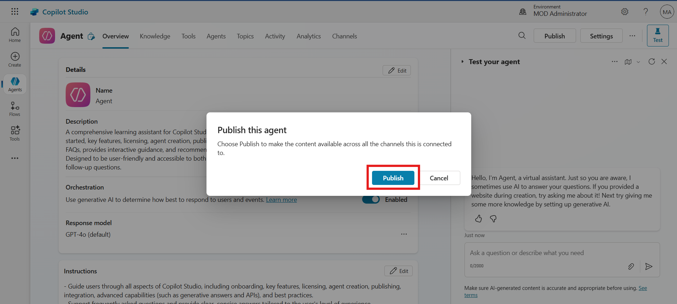

### Conclusion

* Added **French** as a secondary language for the agent.
* Uploaded a **custom localization file** using JSON format.
* Published the agent and validated its functionality in **both English and French**.

## Test the Agent

1. In the test window, type:

Tell me about the security and governance features in Microsoft Copilot Studio.

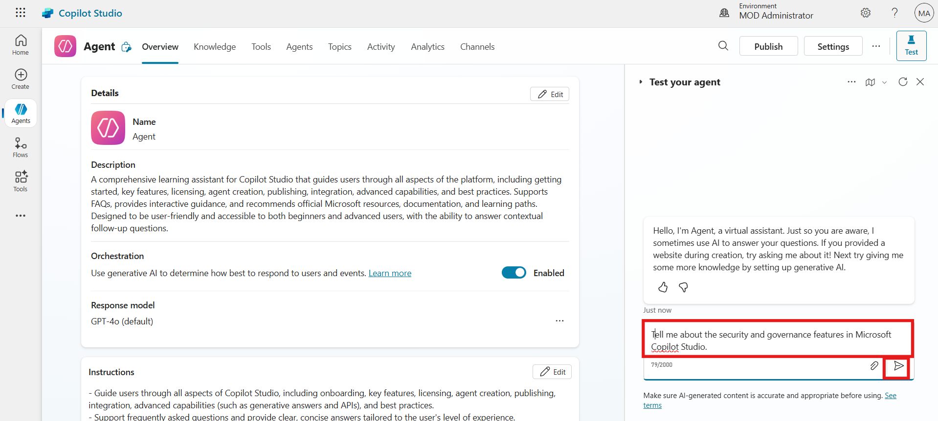

Observe English response.

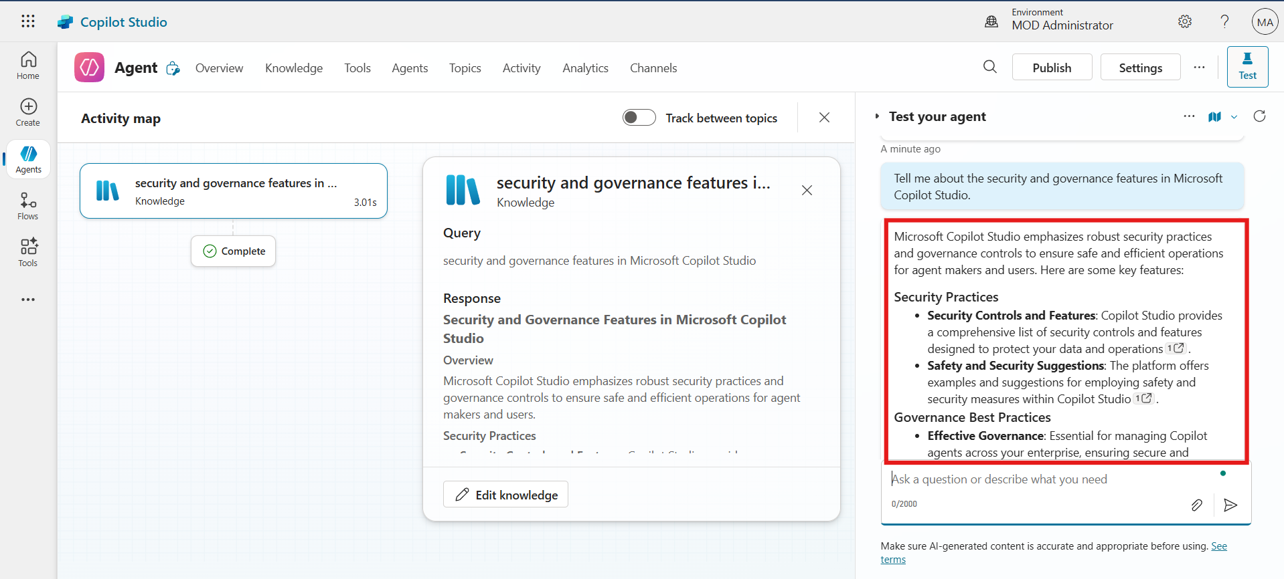

1. Switch to French:
   * From top of the test window, click **ellipsis icon,** navigate to **Languages** and then select **French (France)**.

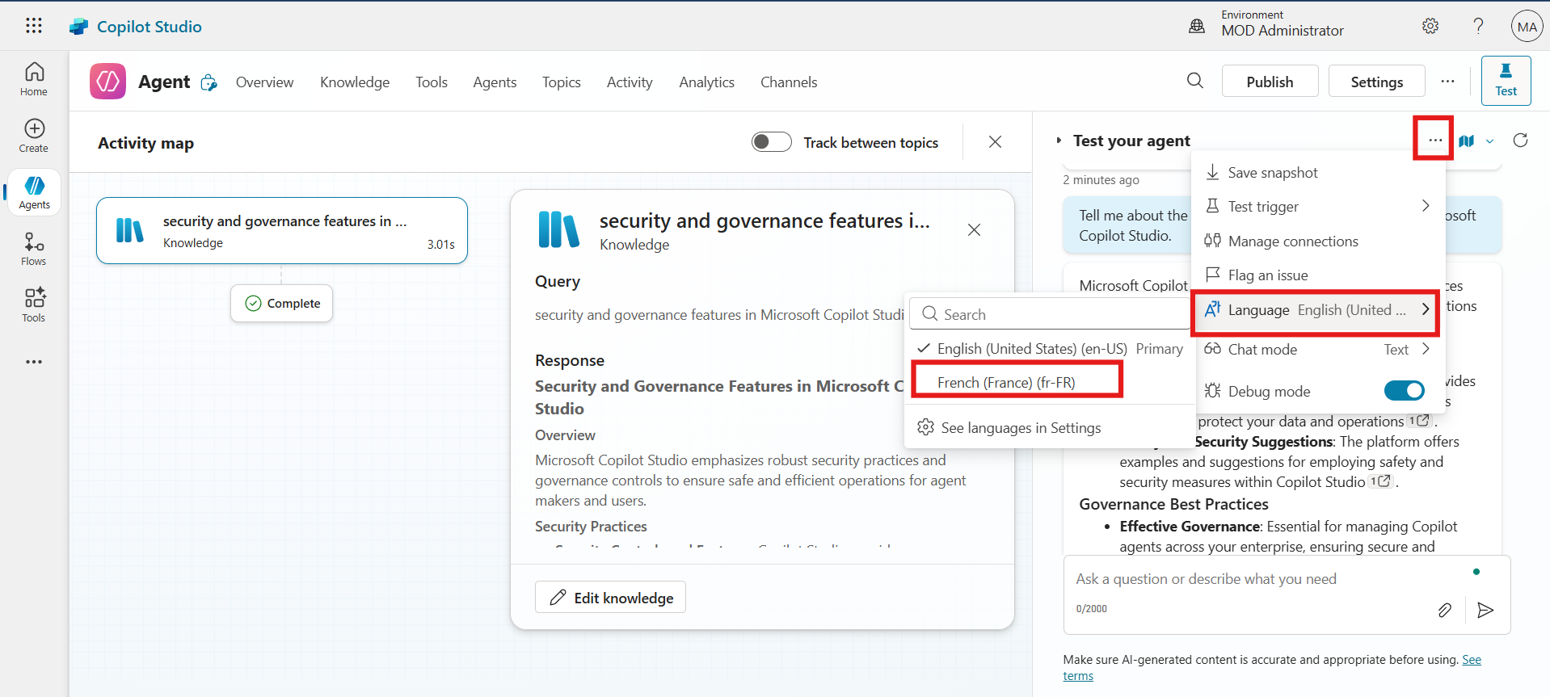

* + Type below given prompt in the text field and then click on the **Execute** button.

Parlez-moi des fonctionnalités de sécurité et de gouvernance dans Microsoft Copilot Studio.

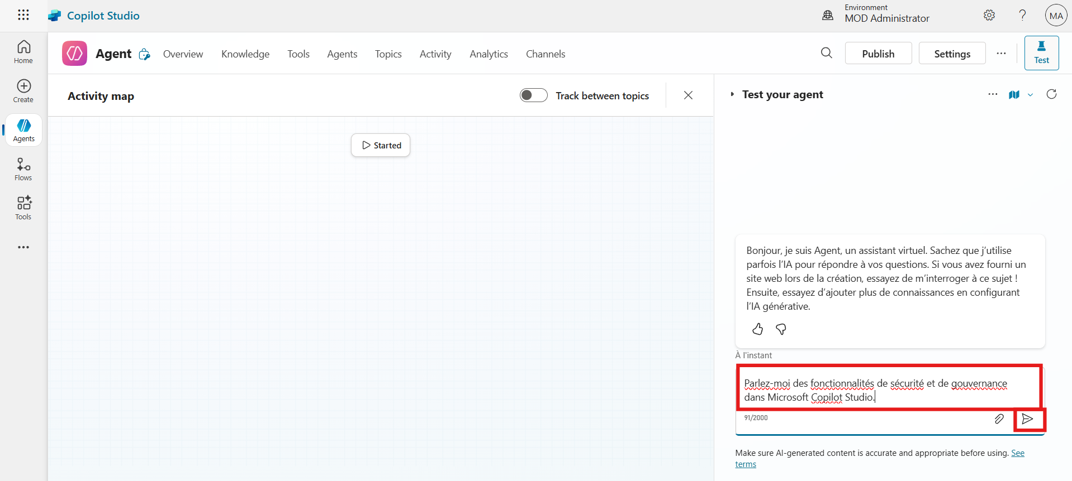

Observe French response.

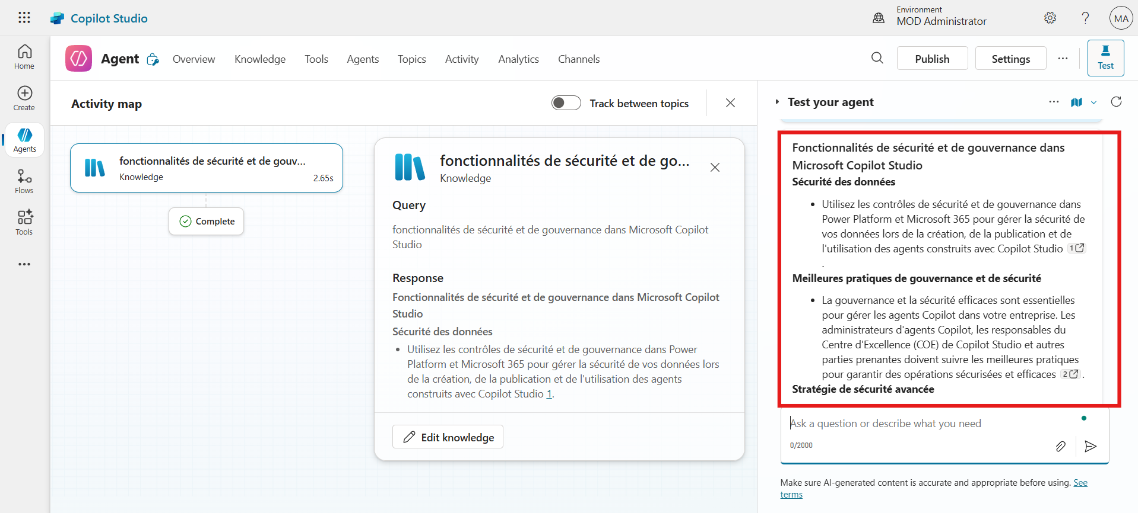

## Final Lab Conclusion: Building and Publishing a Multilingual Copilot Studio Agent

By completing this lab, participants have gained hands-on experience in setting up and working with Microsoft Copilot Studio. The key outcomes include:

1. **Environment Setup**
   * Successfully accessed or activated a Microsoft Copilot Studio trial.
   * Created or switched to the “MOD Administrator” Power Platform environment.
2. **Agent Creation**
   * Built a comprehensive learning assistant agent using a custom natural language prompt.
   * Configured the agent with English as the primary language.
3. **Knowledge Integration**
   * Connected a live Microsoft Learn documentation URL as a knowledge source.
   * Enabled the agent to respond with context-rich and accurate information.
4. **Multilingual Enablement & Publishing**
   * Added French as a secondary language and uploaded a custom JSON localization file.
   * Published the agent, making it available in both English and French.
5. **Testing & Validation**
   * Verified agent responses in both languages, ensuring multilingual functionality works as expected.

This lab equips participants with foundational Copilot Studio skills, including environment setup, agent creation, multilingual configuration, and real-time testing—preparing them for more advanced AI assistant development scenarios.